**Lesson Notes**

1. What is the main purpose of an Operating System?

- Simpler / More Efficient Application Programs

Operating System handles the Computer Hardware

Operating System handles resource allocation

- Consistent User Experience

Operating System provides a standard User Interface (Windows)

Operating System provides a standard way to store and browse data files and folders (File Explorer)

- Allow Multiple Applications Running At Same Time

Operating System Provides Ownership Control (User Accounts)

Operating System Schedules the CPU (Task Sharing)

1. What is the difference between Operating System Software and Use Application Software?

- User Interface

Applications focus on what is contained and displayed within a window

Operating System controls opening / closing / resizing windows and responding to mouse and keyboard actions

Operating System provides standard ways to print, save and open files, access the internet, etc.

- Resource Allocation

Applications just ask for what they need (e.g. Memory, Disk Space)

Operating System checks for availability and access permission

Operating System coordinates resource allocation between applications

1. What is the difference between Operating System Software and Computer Hardware?

- Hardware Independence

Same applications can run on different computer hardware

Operating System must be configured according to hardware components present in the computer

1. What are the main parts of an Operating System?

- Graphical User Interface (GUI)

- Windows Display, mouse, keyboard, sound, etc.

- System Calls

- Device Drivers

- I/O Manager

- Memory Manager

- Process Manager

- Security Monitor

1. What are some popular operating systems?

- Windows OS

- Mac OS

- Linux / Unix

- Android

- iOS

**Reference Diagram**

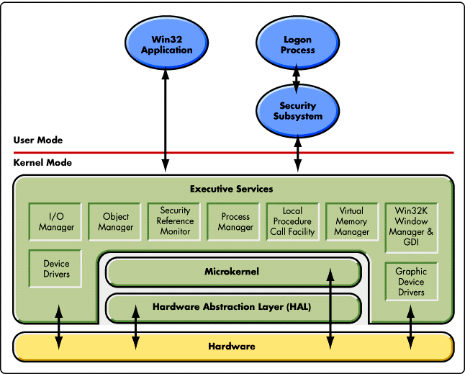

**Student Questions**

1. What is a device driver?
   1. Provide a brief summary

- In computing, a device driver is a computer program that operates or controls a particular type of device that is attached to a computer.

- Drivers are hardware dependent and operating-system-specific.

* 1. List some devices that require a device driver.

- Printer drivers.

- Display drivers.

- ROM drivers.

- BIOS driver.

- USB drivers.

- VGA drivers.

- Sound card Driver.

- Motherboard drivers.

* 1. Provide a label on the reference diagram for the location of a device driver for your graphics card.

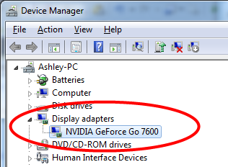

* 1. Provide a label on the reference diagram for the location of a device driver for a locally attached printer.

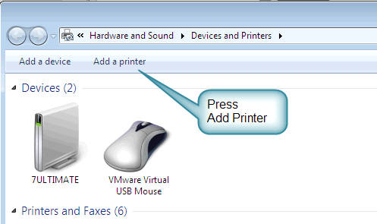

1. What is a DLL?
   1. Provide a brief summary

- It is a dynamic link library file format used for holding multiple codes and procedures for Windows programs. DLL files were created so that multiple programs could use their information at the same time, aiding memory conservation.

* 1. Explain how DLLs are related to user application programs

- DLLs are related to user application programs since it helps with allowing multiple things to run, since they can all run at the same time, instead of individually.

* 1. Provide a label on the reference diagram for the location of a DLL

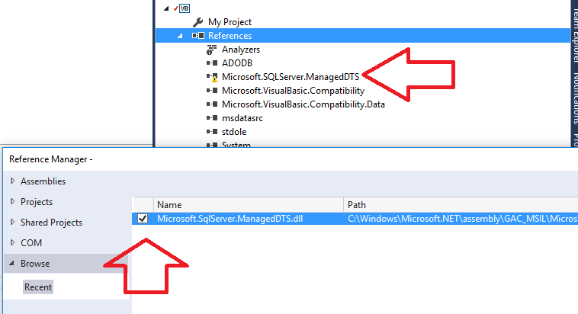

1. What is a windows manager?
   1. Provide a brief summary

- A Window Manager is a program responsible for coordinating all the windows on the screen

* 1. Explain how a windows manager is related to user application programs

- It is related since it allows the user to view multiple application windows at once, instead of one at a time. It is also very efficient

* 1. Provide a label on the reference diagram for the location of a DLL

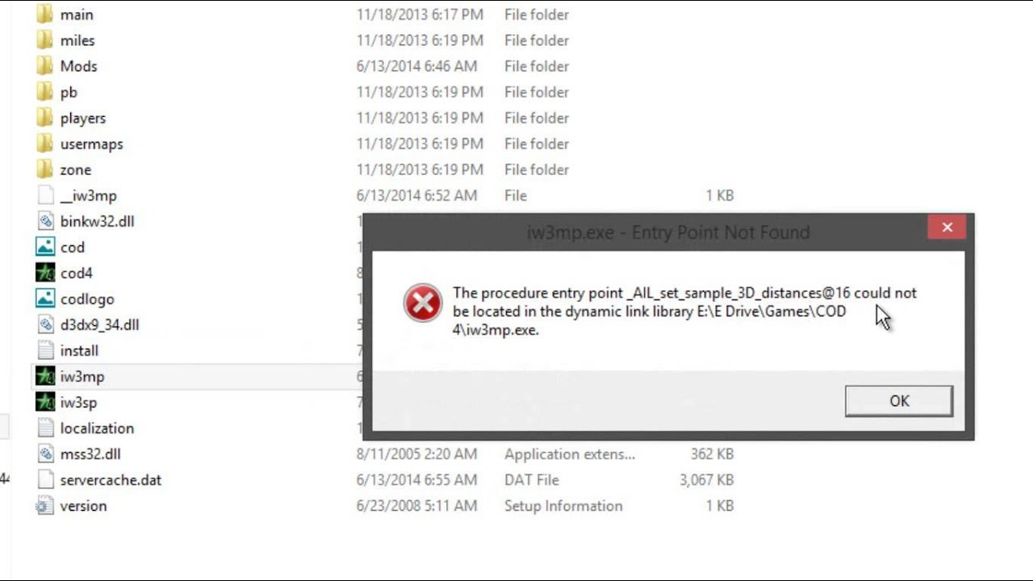

1. What is the windows task manager?
   1. Provide a brief summary

- Task Manager is a Windows feature that provides details about programs and processes running on your computer. It also displays the most commonly used performance measures for processes. Using the Task Manager can provide you with details on current programs, and see which programs have stopped responding.

* 1. List and explain four (4) types of system information provided by the task manager

- CPU usage

- Memory usage

- Disk usage

- Network usage

* 1. Provide a label on the reference diagram for the operating system components related to each type of information.

